RS 101

Requirement Specification
Document (RSD)
<Project Name>

Author: <Author name>
Last Updated Date: <Date of Release>



Plot 520, Road # 27
Jubilee Hills, Hyderabad - 33
www.indussoftware.com

[Note: Text displayed in <brackets> in this template is included to provide guidance to the author and should be deleted before publishing the document. Text displayed in black color may be used as it is by the author of the documents. However, the author is expected to go through this content in the black color and change it as may be required before publishing the document. Author also has to delete this Note before publishing the document. Process introduction may be retained as it is, as that can be useful till the document is base lined.]

Document Status Sheet

Originated by: <Author Name> |  | Approved by: <Approver’s Name>
Issue (Draft/Regular) | Revision | Date | Reason for change

Process Introduction:

Entry Criteria:
Market Requirements/ Planned Feature Lists received:
- in the defined formats,
- received as per the defined process and
- from the defined sources.

Exit Criteria:
Requirement Specification Document (RSD) along with the:
- GUI wireframes (where required),
- reviewed and signed-off ahead of design and
- base lined after the release of software.

Key Activities:
- Collect the requirements
- Derive the specifications
- Analyze the requirements and specifications
- Impact analysis
- GUI mock-ups/ Wireframes development
- Document (Draft) Distribution
- Review and Sin-off of the Documents
- Closure analysis (for measurements)
- Base line the document

Table of Contents

1. Entry Criteria 4
2. Executive Summary 4
2.1. Document Purpose and Audience 4
2.2. Project Overview 4
2.3. Purpose and Scope 4
2.4. Product Context 4
2.5. User Characteristics 5
2.6. Assumptions 5
2.7. Constraints 6
2.8. Dependencies 6
2.9. Definitions, Acronyms and Abbreviations 6
2.10. References 6
3. Requirements 6
4. Requirements Analysis 7
4.1. Requirements 7
4.1.1. Requirement 1 7
4.1.1.1. Analyzed and Elaborated 7
4.1.1.2. Data Flow Diagram 7
4.1.1.3. Use Cases 8
4.1.1.4. Activity/Swim Lane Diagram 9
4.1.1.5. Logical Data Model 10
4.1.1.6. [Non-Functional Requirements] 11
4.1.1.7. User Interfaces 14
4.1.1.8. Acceptance Criteria and Use Case Matrix 15
4.1.1.9. Affected Transactions/Reports 15
4.2. Swim Lane Diagram at the Project Level 15
4.3. Non-Functional Requirements at the Project Level 15
5. Comments exchange for review/sign-off: 18
6. Exit Criteria 19

Entry Criteria
Requirement Documents, Communications received from the Customer:

Document / Communication  Reference | Date | Remarks

Executive Summary
This provides an overview of the entire project/document, purpose and scope of the work, intended audience, assumptions, constraints etc. This section also gives the meanings for any definitions, acronyms used etc.

Document Purpose and Audience
<Present here the purpose of the document and the intended audience of the document>

Project Overview

<Describe here the overview of the project or product and its intended audience>.

Purpose and Scope

<Describe the purpose of the project, while making references to its intended audience of the project deliverables. Also mention, what is within the scope of work. Many times, it makes lot of sense to include what is outside of the scope of these specifications. For example:
In scope
The work includes Workflow Management of the PMS Form, in the areas of:
- Comments Management.
- Create New Workflow for Special Review Type.

Out of Scope
The work excludes in Comments Management in the area of:
Sending the comments from the Protocol Form itself.>

Product Context

<How does this product relate to other products, especially after implementing this new project? Is it independent and self-contained? Does it interface with a variety of related systems? Describe these relationships or use a diagram to show the major components of the larger system, interconnections, and external interfaces.
An example Context Diagram, taken from a GMS project:
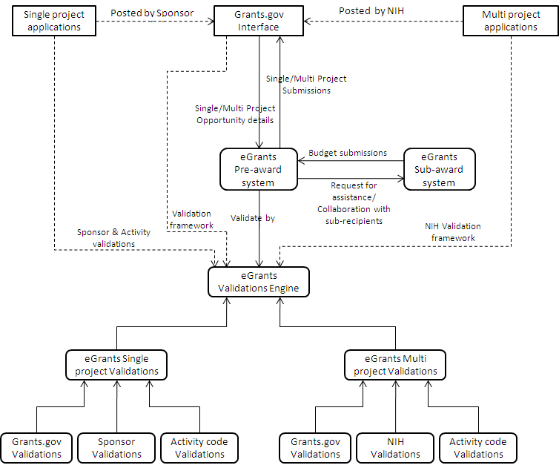
>

User Characteristics

<Create general customer profiles for each type of user who will be using the product. Profiles should include:
- student/faculty/staff/other
- experience
- technical expertise
- other general characteristics that may influence the product>

Assumptions

<List any assumptions that affect the requirements, for example: user expertise, operating system, client browser, scope of work included, excluded scope of work etc.>. If some of them change, the Requirements Specification may be subject to change accordingly and the document cannot be treated as an official and controlled one, unless it is issued again by the author making references to those changes from the assumption.

.

Constraints

<Describe any items that will constrain the design options, including
- parallel operation with an old system
- audit functions (audit trail, log files, etc.)
- access, management and security
- criticality of the application
- system resource constraints (e.g., limits on disk space or other hardware limitations)
- other design constraints (e.g., design or other standards, such as programming language or framework)>

Dependencies

<List the dependencies that affect the requirements. Examples:
- This new product will require a daily download of data from X,
- Module X needs to be completed before this module can be built.>

Definitions, Acronyms and Abbreviations

References

Requirements
- <Describe all system requirements in enough detail for designers to design a system satisfying the requirements and testers to verify that the system satisfies requirements.
- Organize these requirements in a way that works best for the project.
- Describe every input into the system, every output from the system, and every function performed by the system in response to an input or in support of an output. (Specify what functions are to be performed on what data to produce what results at what location for whom.)
- Each requirement should be numbered (or uniquely identifiable) and prioritized.

See the sample requirements in Error: Reference source not found, and Error: Reference source not found, as well as these example priority definitions>

This is the list of requirements that make-up the project. <The content given in the table is for example purpose and shall be replaced with the actual content for this project>
Req# | Requirement | Comments
 | Modify the Comments and Review Cycle in line with the UMN requirements | This included the changes to the emailing process
 | Create a New Workflow Type in line with the UMN requirements | This includes the changes to emailing process

Requirements Analysis

Requirements

This gives the analysis for each requirement, one after the other, along with the receiving details, maximum elaboration possible with clear understanding and further the analysis like the data flow required for meeting the requirement, use cases etc.

Requirement 1

<Present here the content as received vide document / any formal communication for this requirement. A requirement can have one use case or more than one use case. Similarly one use case may cover more than one requirement. A Requirement may be a New Requirement or an Enhancement or a Change Request. In case of Change Request, add the change request to Change Requirement Register. Give the reference of the Requirement Number, while presenting a requirement here.>

Analyzed and Elaborated

<Elaborate each requirement to the extent required over and above the way the customer has described the requirement. This elaboration may play vital role to enable the author and audience to develop better understanding on the requirement.>

Data Flow Diagram

<Present here the information flow for the requirement, either diagrammatically or as descriptive steps or as a combination of both, the best possible case. Explanation through dataflow diagrams can give the best results. The data flow analysis that cut through the various components of the project requirement or at the project level can be shown as part of the swim lane diagram, given at the later part of the document. A data flow diagram can be shown in the horizontal format or vertical format, the way it can be useful to the audience.

An example Data Flow Diagram, taken from a GMS project:
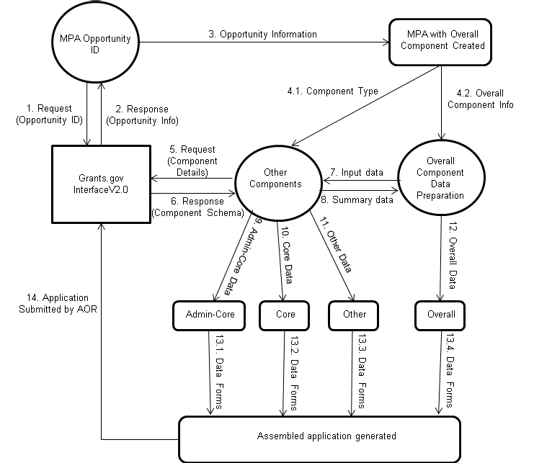
>

Use Cases

<A requirement or a part of a requirement or a combination of requirements can be expressed in the format of a Use Case as given under. Give all the applicable use cases with different use case reference identity, if there are more than one possible for the requirement: >
<Use Case ID: Project Reference. X. Serial Number of the Use Case. >
Example Use Case ID: 2.4.19.1, X. 001.
Use Case ID | <Acronym.Sl No>
Summary | <Summary type Description of the Use Case, generally not more than three lines. Example: Buy stocks over the web>
Actor | <Identify the Actors of this Use Case. It can be a Role or sometimes it can even be the system itself. For the example use case it is: Purchaser >
Pre-Condition | <State that should already exist by the time the Actor initiates the use case. For the example use it can be: Purchaser should have been registered. >
Basic Course of Events | <Describe the processing path to execute the use case. This shall be presented in steps / points for easy understanding. For the example use case, it can be as under:  1. User selects to buy stocks over the web.  2. System gets name of web site to use (E*Trade, Schwabb, etc.)  3. System opens web connection to the site, retaining control.  4. User browses and buys stock from the web site.  5. System intercepts responses from the web site, and updates the user's portfolio.  6. System shows the user the new portfolio standing. >
Post-Conditions | < List the state, the system can be in when the use case ends. This can be presented in number of steps / points as may be required. For the example use case, it can be as under:  - email is sent to the Purchaser confirming the order  - System puts the order for processing >
Related Business Rules / Validations / Exceptions | <List the business rules or validations or exceptions that may influence the use case>
Mock-Up Reference | <Screen ID of the UI developed>
Level of Understanding | <Perceived Level of Understanding (of the Author) of the sub-requirement in Percentage by the time the document last published. E.g., 70%>
>

Activity/Swim Lane Diagram

<A swim lane is a visual representation of a business process or a business requirement. For this level, it will be very useful in showing the connections and the interactions among the detailed or summarized flow diagrams of different components of the project requirement and the components of the rest of the product. Swim lanes may be arranged either horizontally or vertically. In the accompanying example, the swim lanes are arranged vertically.

An example Swim Lane Diagram, taken from a GMS project:

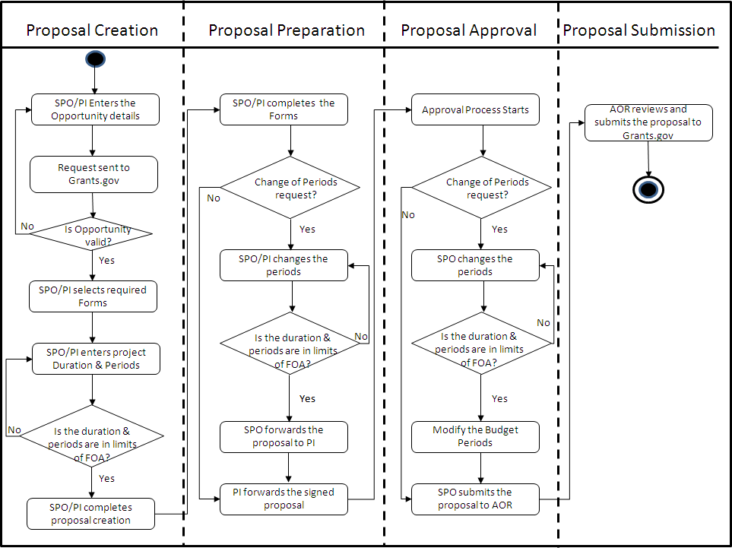

Logical Data Model

<A logical data model describes the data in as much detail as possible, without regard to how they will be physically implemented in the database. Features of a logical data model include:
- Includes all entities and relationships among them.
- All attributes for each entity are specified.
- The primary key for each entity is specified.
- Foreign keys (keys identifying the relationship between different entities) are specified.
- Normalization occurs at this level.
The steps for designing the logical data model are as follows:
- Specify primary keys for all entities.
- Find the relationships between different entities.
- Find all attributes for each entity.
- Resolve many-to-many relationships.
- Normalization.
The figure below gives two examples for a logical data model.
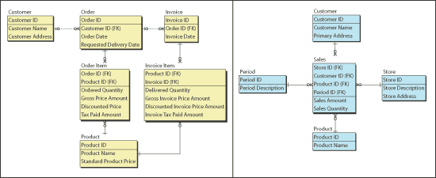
>

[Non-Functional Requirements]

This is the list of non-functional requirements that make-up for the targeted requirements. These requirements can be in the areas of performance, security, usability, user experience etc. Elaborate the requirement.

<The content given in the table is for the example purpose and shall be replaced with the actual content for this project.>

Req# | Requirement | Comments
 | <User Interface: In addition to functions required, describe the characteristics of each interface between the product and its users (e.g., required screen formats/organization, report layouts, menu structures, error and other messages, or function keys).>
<Usability: Include any specific usability requirements, for example, Learnability.
The user documentation and help should be complete
The help should be context sensitive and explain how to achieve common tasks.
The system should be easy to learn
(See http://www.usabilitynet.org/) >

 | <Performance – Capacity: <Include measurable capacity requirements (e.g., the number of simultaneous users to be supported, the maximum simultaneous user load, per-user memory requirements, and expected application throughput).>
<Performance – Availability: Include specific and measurable requirements for:
- Hours of operation
- Level of availability required
- Coverage for geographic areas
- Impact of downtime on users and business operations
- Impact of scheduled and unscheduled maintenance on
- uptime and maintenance communications procedures
- Reliability (e.g., acceptable mean time between failures
- (MTBF), or the maximum permitted number of failures
- per hour).>

 | <Performance – Latency: Include explicit latency requirements, e.g., the maximum acceptable time (or average time) for a service request.>
 | <Maintainability – Monitoring: Include any requirements for product or service health monitoring, failure conditions, error detection, logging, and correction.>
 | <Maintainability – Maintenance: Specify attributes of the system that relate to ease of maintenance. These requirements may relate to modularity, complexity, or interface design. Requirements should not be placed here simply because they are thought to be good design practices.>
<Maintainability – Operations: Specify any normal and special operations required by the user, including:
- periods of interactive operations and periods of
- unattended operations
- data processing support functions
- backup and recovery operations
- safety considerations and requirements
- disaster recovery and business resumption>

<Security – Protection: Specify the factors that will protect the system from malicious or accidental access, modification, disclosure, destruction, or misuse. For example:
- encryption
- activity logging, historical data sets
- restrictions on inter module communications
- data integrity checks>

 | <Security – Authorization/Authentication: Specify the Authorization and Authentication factors. Consider using standard tools such as Pub Cookie.>
 | <Network and Hardware Interfaces: Specify the logical characteristics of each interface between the product and the hardware or network components of the system. This includes configuration characteristics (e.g., number of ports, instruction sets), what devices are to be supported, and protocols (e.g., signal handshake protocols).>
<System Interfaces: Specify the use of other required products and interfaces with other systems. For each interface, define the interface in terms of message format and content. For well-documented interfaces, simply provide a reference to the documentation. Example systems interface requirements:
- System-to-System Live Interface
  - eGrants system sends the proposal from the User’s server to the Grants.gov server.
  - The following need to be managed to ensure the success of this transaction:
  - The file format.
  - The content conformance.
  - The certificate of the User Company.
  - The AOR authentication
  - Failure Mechanism etc.>,

<Portability: If portability is a requirement, specify attributes of the system that relate to the ease of porting the system to other host machines and/or operating systems. For example,
- Percentage of components with host-dependent code;
- Percentage of code that is host dependent;
- Use of a proven portable language;
- Use of a particular compiler or language subset;
- Use of a particular operating system;
- The need for environment-independence - the product
- must operate the same regardless of operating
- systems, networks, and development or production
- environments.>

 | <Technology/Architecture: Mention the architecture to use and the technologies to use. If there is no change in the technology stack or the architecture, specify that there are no changes expected in these areas.>
 | <User Tools: Specify the tools the user is expected to use, while using this requirement/system. Example tools are browsers>

User Interfaces

<Develop and Present the Requirements in the form of User Interfaces/ Wireframes. Give here all such User Interfaces applicable for the entire Project, with references to the Requirements and with Screen Identifications. This will enable the reviewers to assess whether the authoring team has correctly understood the requirements. The screens will have to be corrected to take care of the reviewers’ feedback to get the sign-off for the RSD.>

Acceptance Criteria and Use Case Matrix

<Establish here the relation between the high-level expected deliverables of the requirement and the identified use cases. May give appropriate Remarks, where required. Expected Deliverables are presented in this table as Acceptance Criteria. In a way these acceptance criteria should help / drive the understanding and development of the Requirement. This means, when the Requirement is developed in such a way that it meets the identified acceptance criteria, the requirement development presented in the document can be termed successful. To establish the fact of meeting the criteria, the authoring team has to map the acceptance criteria with the identified Use Case Ids. The success of using this section will be more, when the customer defines these criteria. >

Acceptance Criterion | Use Case ID | Remarks

Affected Transactions/Reports

<Present here the impact of the requirement in terms of impacted transactions and reports in the existing system. Impact at this stage is assessed at the functional level and this information may be useful, while documenting the technical impact at the LLD Phase. However, this impact has to be used only as a reference, but not as dependable information for the LLD Phase.>

Transactions:
Reports:

Swim Lane Diagram at the Project Level

<A swim lane is a visual representation of a system or a business process or a business requirement. For this level, It will be very useful in showing the connections and the interactions among the detailed or summarized flow diagrams of different project requirements of the project and the components of the rest of the product. Swim lanes may be arranged either horizontally or vertically. In the accompanying example, the swim lanes are arranged vertically.

For an example, may use the Swim Lane Diagram, shown at the requirement level>:

Non-Functional Requirements at the Project Level

This is the list of non-functional requirements that make-up for the targeted requirements. These requirements can be in the areas of performance, security, usability, user experience etc. Elaborate the requirement.

<The content given in the table is for the example purpose and shall be replaced with the actual content for this project.>

Req# | Requirement | Comments
 | <User Interface: In addition to functions required, describe the characteristics of each interface between the product and its users (e.g., required screen formats/organization, report layouts, menu structures, error and other messages, or function keys).>
<Usability: Include any specific usability requirements, for example, Learnability
The user documentation and help should be complete
The help should be context sensitive and explain how to achieve common tasks
The system should be easy to learn
(See http://www.usabilitynet.org/) >

 | <Performance – Capacity: <Include measurable capacity requirements (e.g., the number of simultaneous users to be supported, the maximum simultaneous user load, per-user memory requirements, and expected application throughput).>
<Performance – Availability: Include specific and measurable requirements for:
- Hours of operation
- Level of availability required
- Coverage for geographic areas
- Impact of downtime on users and business operations
- Impact of scheduled and unscheduled maintenance on
- uptime and maintenance communications procedures
Reliability (e.g., acceptable mean time between failures
(MTBF), or the maximum permitted number of failures
per hour).>

 | <Performance – Latency: Include explicit latency requirements, e.g., the maximum acceptable time (or average time) for a service request.>
 | <Maintainability – Monitoring: Include any requirements for product or service health monitoring, failure conditions, error detection, logging, and correction.>
 | <Maintainability – Maintenance: Specify attributes of the system that relate to ease of maintenance. These requirements may relate to modularity, complexity, or interface design. Requirements should not be placed here simply because they are thought to be good design practices.>
<Maintainability – Operations: Specify any normal and special operations required by the user, including:
- periods of interactive operations and periods of
- unattended operations
- data processing support functions
- backup and recovery operations
- safety considerations and requirements
- disaster recovery and business resumption>

<Security – Protection: Specify the factors that will protect the system from malicious or accidental access, modification, disclosure, destruction, or misuse. For example:
- encryption
- activity logging, historical data sets
- restrictions on inter module communications
- data integrity checks>

 | <Security – Authorization/Authentication: Specify the Authorization and Authentication factors. Consider using standard tools such as Pub Cookie.>
 | <Network and Hardware Interfaces: Specify the logical characteristics of each interface between the product and the hardware or network components of the system. This includes configuration characteristics (e.g., number of ports, instruction sets), what devices are to be supported, and protocols (e.g., signal handshake protocols).>
<System Interfaces: Specify the use of other required products and interfaces with other systems. For each interface, define the interface in terms of message format and content. For well-documented interfaces, simply provide a reference to the documentation. Example systems interface requirements:
- System-to-System Live Interface
  - eGrants system sends the proposal from the User’s server to the Grants.gov server.
  - The following need to be managed to ensure the success of this transaction:
  - The file format.
  - The content conformance.
  - The certificate of the User Company.
  - The AOR authentication
  - Failure Mechanism etc.>,

<Portability: If portability is a requirement, specify attributes of the system that relate to the ease of porting the system to other host machines and/or operating systems. For example,
- Percentage of components with host-dependent code;
- Percentage of code that is host dependent;
- Use of a proven portable language;
- Use of a particular compiler or language subset;
- Use of a particular operating system;
- The need for environment-independence - the product
- must operate the same regardless of operating
- systems, networks, and development or production
- environments.>

 | <Technology/Architecture: Mention the architecture to use and the technologies to use. If there is no change in the technology stack or the architecture, specify that there are no changes expected in these areas.>
 | <User Tools: Specify the tools the user is expected to use, while using this requirement/system. Example tools are browsers>

Comments exchange for review/sign-off:
<Here all the review comments by the Reviewers from the Indus team or US team will be captured. The Reviewer has to write his/her comments with reference to the specific section and the specific context. Whenever a document is saved with new set of comments at the review stage, the version number of the document has to be increased. Sign-off has to be written in the Comments column, when the RSD is approved. >

Team / Person | Date | Comments

Exit Criteria
Sign Off Particulars

Sign-Off Particulars:
Measure | Approved by and Date | Communication Reference for the Approval
IDC Approval
KSI Approval 1
KSI Approval 2

